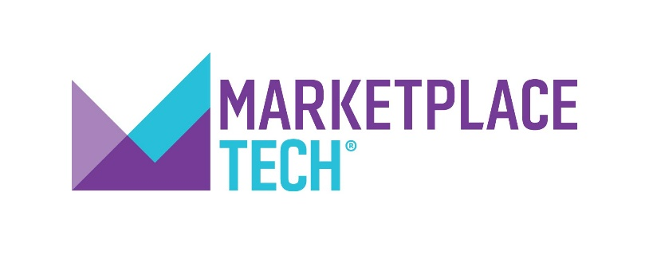
[YOUR STATION LOGO HERE]

Contact: {Local Station Contact]
[EMAIL]
[PHONE]

[STATION] ANNOUNCES ADDITION OF MARKETPLACE TECH™
TO AIR [DAY OF WEEK AND TIME]

[DATELINE]— [STATION] is proud to bring Marketplace Tech™ to audiences starting [DATE] [at time slot}. Hosted by Molly Wood, and produced by American Public Media, the show focuses on demystifying the digital economy for listeners, uncovering how major technology themes connect to our daily lives.

Marketplace Tech is a guide to the business behind the technology that’s changing our lives. The show tells the stories of modern life through our digital economy, ranging from how tech is changing the nature of work, to exploring the digital divide, to explaining how venture capital works. As part of the Marketplace® portfolio of programs, the show uses global technology themes to further the Marketplace mission of raising the economic intelligence of the country, highlighting how technology is shaping our economic futures.

[QUOTE FROM GM OR PD HERE ABOUT ADDING THE PROGRAM.]

[STATION IDENTIFYING PARAGRAPH]
About the Host
Molly Wood (@mollywood) is the host and senior editor of Marketplace Tech. As one of the most respected tech journalists in the country, her resume includes working as a tech columnist at The New York Times and as an executive editor at CNET. She also co-hosts the podcast Make Me Smart with Kai and Molly™ . As a pioneer of podcasting, she has covered the tech industry across all platforms and is a regular contributor in radio, television and print.

###

About Marketplace
Marketplace® is on a mission to raise the economic intelligence of the country. Its core programs – Marketplace®, Marketplace Morning Report® and Marketplace Tech® – are currently broadcast on more than 800 public radio stations nationwide and heard by more than 14 million weekly listeners. Marketplace podcasts including Make Me Smart with Kai and Molly, The Uncertain Hour® and Corner Office can be found at Marketplace.org or on your favorite podcast app. The Marketplace portfolio of programs are produced and distributed by American Public Media®, one of the largest producers and distributors of public radio programming in the world. For more information on Marketplace, visit marketplace.org, follow us on Twitter @marketplace or like us on Facebook. For more information on American Public Media, visit americanpublicmedia.org.

About American Public Media
American Public Media® is the national programming division of Minnesota Public Radio® and reaches 20 million listeners via 1,000 radio stations nationwide each week. APM is one of the largest producers and distributors of public radio programming in the world, with a portfolio that includes BBC World Service, Marketplace®, and the leading classical music programs in the nation. APM offers a diverse array of podcasts featuring the best in food, culture, entertainment, business and investigative journalism. For more information on APM, visit americanpublicmedia.org.

Source: Data are copyright Nielsen Audio. Data are estimates only.

